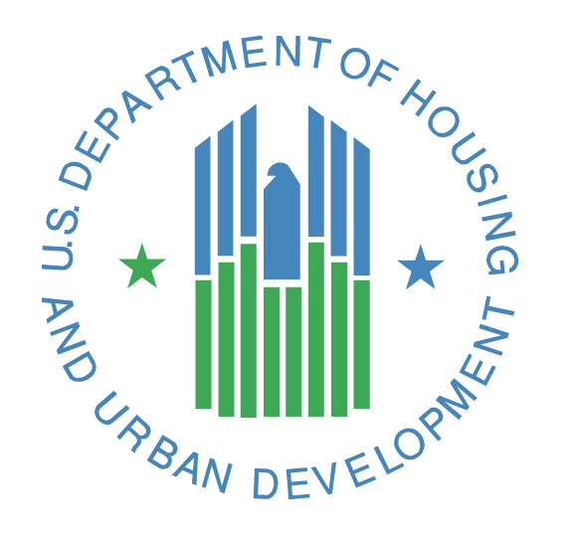
Useful Phone Numbers

HUD Des Moines Office
Phone: (515) 284-4512
Email: IA_Webmanager@hud.gov

Housing Authorities by Cities
Boone: (515) 968-1882
Chariton: (641) 774-2725
Creston: (641) 782-8585
Des Moines: (515) 323-8950
Marshalltown: (614) 754-5756
Osceola: (712) 262-7460
Webster City: (515) 573-7751

Resources
Iowa Department of Human Services: (800) 972-2017
Iowa 211: 211
Iowa Legal Aid: (800) 532-1275
United Way: (515) 246-6500
USDA: (515) 284-4663

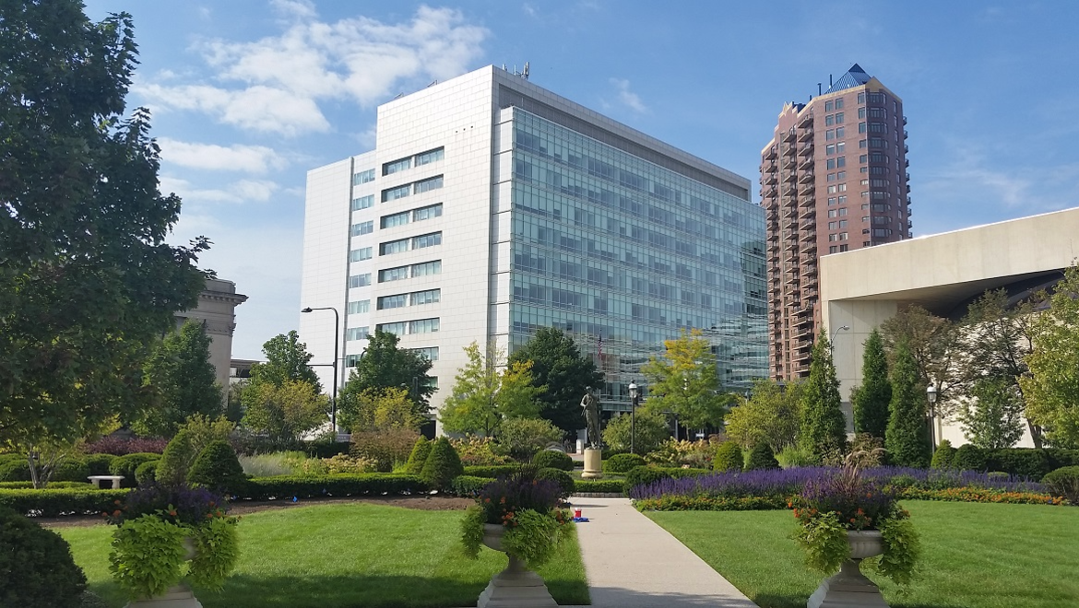
U.S. Dept. of Housing and Urban Development
210 Walnut Street, Room 937
Des Moines, Iowa 50309

U.S. Department of Housing and Urban Development

Housing
You can apply for housing programs at individual housing authorities, agencies, or at individual HUD Multifamily apartments. It’s okay to be on multiple waiting lists.

Housing Authorities (HA) – Apply for public housing or section 8 vouchers. Some Housing authorities have websites and take applications online. For a complete listing of housing authorities in Iowa, visit: https://www.hud.gov/sites/dfiles/PIH/documents/PHA_Contact_Report_IA.pdf

Des Moines Municipal
Housing Authority
2309 Euclid Ave
Des Moines, IA 50313
(515) 323-8950

Low Rent Housing Authority
of Marshalltown
36 N. Center Street
Marshalltown, IA 50158
(641) 754-5756

Central Iowa Regional
Housing Authority
1201 SE Gateway Drive
Grimes, IA 50111
(515) 986-1882

Warren County Housing Authority
1305 E. 1st Ave, Apt. 1
Indianola, IA 50125
(515) 961-1073

HUD Multifamily Apartments - For a complete listing, visit:
- http://www.hud.gov/apps/section8/index.cfm

HUD Resource Locator is a free app available via Apple iTunes, Google Play Marketplace and also on your browser at resources.hud.gov.

The HUD Resource Locator provides location and contact information for local HUD resources including:
- Public Housing Authorities
- HUD Multifamily Properties
- Low Income Housing Tax Credit Properties
- Public Housing Buildings and Developments
- USDA Rural Housing Properties

Low-Income Housing Tax Credit Housing – Contact IFA to find tax credit properties at (515) 452-0400.
- https://www.iowafinance.com/

US Department of Agriculture Rural Housing Service – The USDA administers housing programs and provides resources for renters, homebuyers, and homeowners.
- https://www.rd.usda.gov/ia

US Department of Veterans Affairs – The VA provides benefits, health care and cemetery services to military veterans. Contact the VA office for more information at: (515)699-5999.
- https://www.va.gov/
Fair Housing
- Disability Rights Iowa (515) 452-0740
  - https://disabilityrightsiowa.org/
- Family Housing Advisory Services (712) 322-4436
  - www.fhasinc.org
- Iowa DHHS: (515) 281-3128
  - https://dhs.iowa.gov/mhds/disability-services

Homelessness
- 211 – Iowa Homeless Hotline 211
  - https://www.211iowa.org/
- Homeward (515) 282-3233
  - https://www.homewardiowa.org
- Family Housing Advisory Services (402) 934-6763
  - www.fhasinc.org
- Institute for Community Alliances (515) 246-6643
  - https://icalliances.org/iowa

Landlord and Tenant
- Home, Inc. (515) 243-1277
  - https://www.homeincdsm.org/
- Iowa Legal Aid (800) 532-1275
  - https://www.iowalegalaid.org
- IMPACT (Utilities) (515) 274-9833
  - https://www.impactcap.org/

Homeownership and Repair
- Greater Des Moines Habitat for Humanity (515) 309-0224
  - https://gdmhabitat.org/services/rocktheblock
- Green Iowa Americorps (515) 471-8686 ext.104
  - https://www.greeniowaamericorps.org/
- Home Improvement Assistance for West Des Moines (515) 273-0770
  - http://www.wdm.iowa.gov/government/community-economic-development/housing/
- HUD Approved Housing Counseling Agencies in Iowa
  - https://www.hud.gov/states/iowa/homeownership/hsgcounseling
- HUD FHA Lender
  - https://www.hud.gov/program_offices/housing/sfh/lender/lenderlist
- HUD Homes for Sale
  - https://www.hudhomestore.gov/Home/Index.aspx
- Neighborhood Finance Corporation (515) 246-0010
  - https://neighborhoodfinance.org/
- Polk County Emergency Repair Program (515) 286-3356
  - https://www.polkcountyiowa.gov/public-works/planning-development/housing-services/emergency-repair/
- Rebuilding Together (515)284-7403
  - http://www.rebuildingdm.org/
- USDA Single Family Programs (515) 284-4663
  - https://www.rd.usda.gov/ia

