For Section 8 & Public Housing Participants

Create and accomplish your goals.

FAMILY SELF-
SUFFICIENCY

Go back to school

Connect to community resources

Escrow Savings Account
Find a job or move ahead in your career

Unlock the tools for improved credit

Homeownership

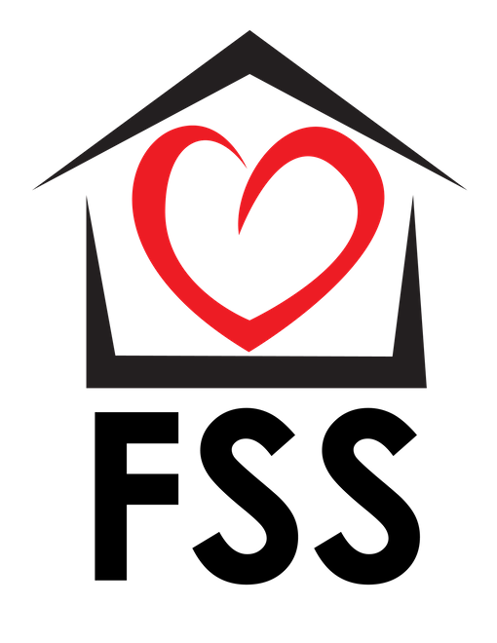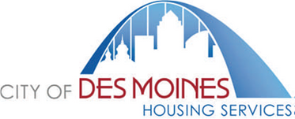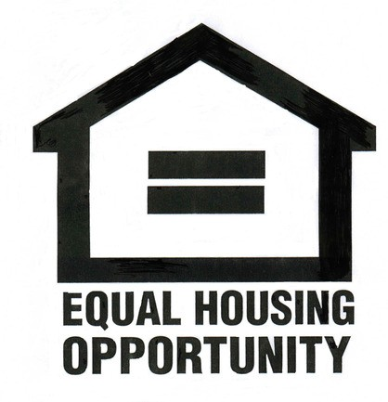
To join FSS call (515)323-8983, (515)323-8973, or (515)323-8969 or return the enclosed form.

MAKE A CHANGE
build a new future

Employment

Homeowner
Education

You

Progress
Community

Resources
Freedom

JOIN FSS !

