Minutes

HBAC Work Session Minutes
February 20, 2019
The meeting was called to order by Blake Hammond at 4:30pm at 2323 Grand Ave.

In attendance
Cathy McKay, Katie Northness, Tanya Stark, Kathleen Wells, Blake Hammond, Pam Bemis, Josh Brown, Sharon Bell, Thomas Ahart, Jill Burnett-Requist, Rossi Frith, Greg Harris and Lyle Stephenson.

Dr. Thomas Ahart
Confirmed he reviewed the recommendations for cost savings within the health insurance and discussed with Chiefs.
Committee compiled recommended changes below that would be presented to the Chiefs with the request this be a three-year commitment on health insurance.
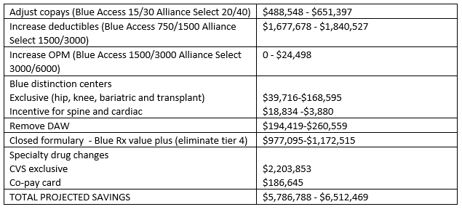

Next Meeting
Wednesday, April 24, 2019
4:30-5:30pm
2323 Grand Avenue Conference Room D

