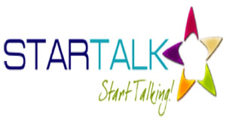
2014 STARTALK Grant for Arabic Language Study
Lincoln High School, Des Moines Public Schools
Application
Arabic Summer Immersion Program 2014
DMPS students will receive 1 semester (.5) language credit based on their level of proficiency at the end.
Grade September 2014 _____________ School _____________________ ID#________________________________
Student Last Name_________________________________ Student First Name___________________________________

Home Address__________________________________________________________________________________________
Street City Zip Code
PLEASE PRINT
Primary email_______________________________________________________________________________________________________
Parent/Guardian Contacts
1st________________________________________________________________________________________________________________
Last Name First Name phone (day) relationship

2nd _______________________________________________________________________________________________________________
Last Name First Name phone (day) relationship

Medical needs: ____________________________________________________________________________________________________
What would you like your teachers to know about you?

Attendance is required for success in the STARTALK Summer Arabic Program. Program begins Friday, June 9 and ends Friday, June 27. Classes will meet from 9:00 am-2:30 pm.
Yes, ___________________ I will be able to attend all class periods.
No, ____________________ I cannot attend all periods because:
Parent /Guardian Signature
___________________________________________________________________________________ date ____________________________
Questions: India Morrow 242. 8452 india.morrow@dmschools.org
Dr. Simone Alekno 242.8504 simone.alekno@dmschools.org

